./myfirstscript

Record a screenshot of successful script execution

./Variable.sh

Verify/Record that the file with your name was created. Record a screenshot of  
successful script execution

./If.sh

Record a screenshot of successful script execution

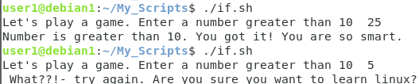

./case.sh

Record a screenshot of successful script execution.

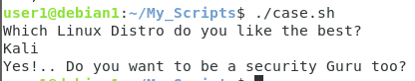

./loop.sh

Record a screenshot of successful script execution

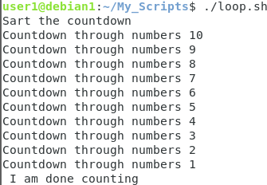

./while.sh

Record a screenshot of successful script execution

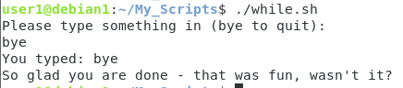

./menu.sh

Record a screenshot of successful script execution

